Ideation Phase Brainstorm & Idea Prioritization

|  |  |
| --- | --- |
| Date | 17-07-2025 |
| Team ID | LTVIP2025TMID51205 |
| Project Name | Lack of interactive visualization to explore world heritage data |
| Maximum Marks | 4 Marks |

**Step-1: Team Gathering, Collaboration and Select the Problem Statement**

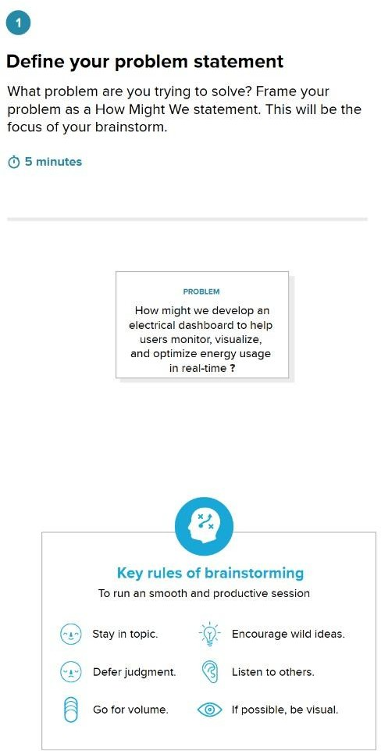

Step-2: Brainstorm, Idea Listing and Grouping

* Visualizing sites by country and region
* Risk level identification (In Danger)
* Time-based inscriptions & forecasts
* Category-wise site distribution
* Region-wise dashboard storytelling

Step-3: Idea Prioritization

